**Find none-finalized events**

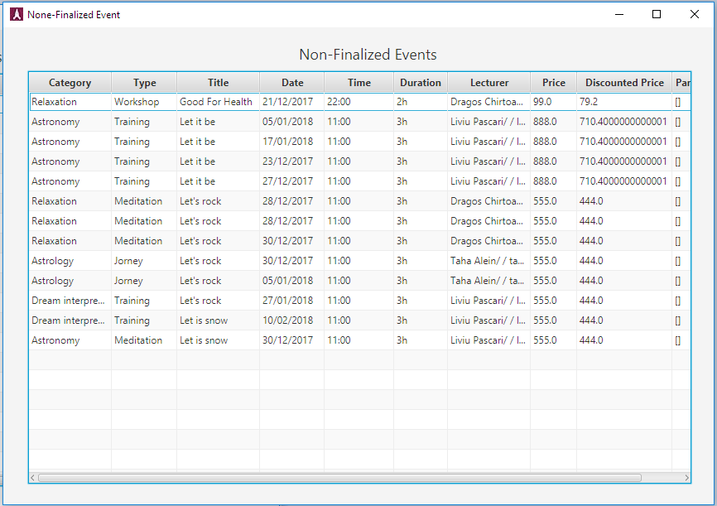

When press on “None-finalized Event” button in main window, the none-finalized events window, will appear, this window all none finalized events will appear one by one, there is a possibility to sort the column, when press on column head.

**Find Finalized events**

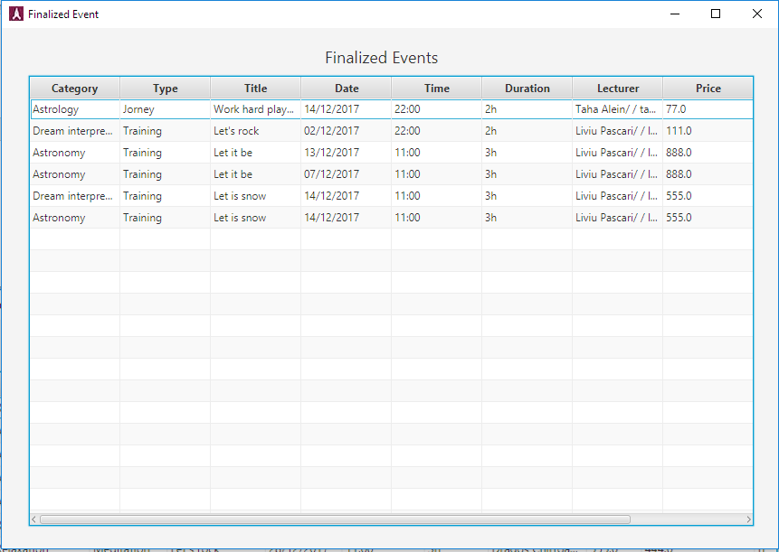

When press on “finalized Event” button in main window, the finalized events window, will appear, this window all finalized events will appear one by one, there is a possibility to sort the column, when press on columns’ head.

**Find Lecturers by category** 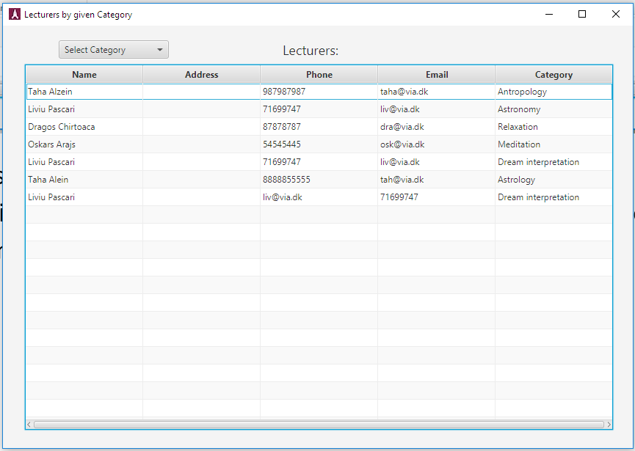

When press on “Lecturers” button in main window, the “lecturers by given category” window will appear, in this window all lecturers will appear one by one, by selecting a category from the “combobox” the lecturers for given category will be shown, otherwise, selecting “show all” will result to show them all again.

**Find Sponsor by category**

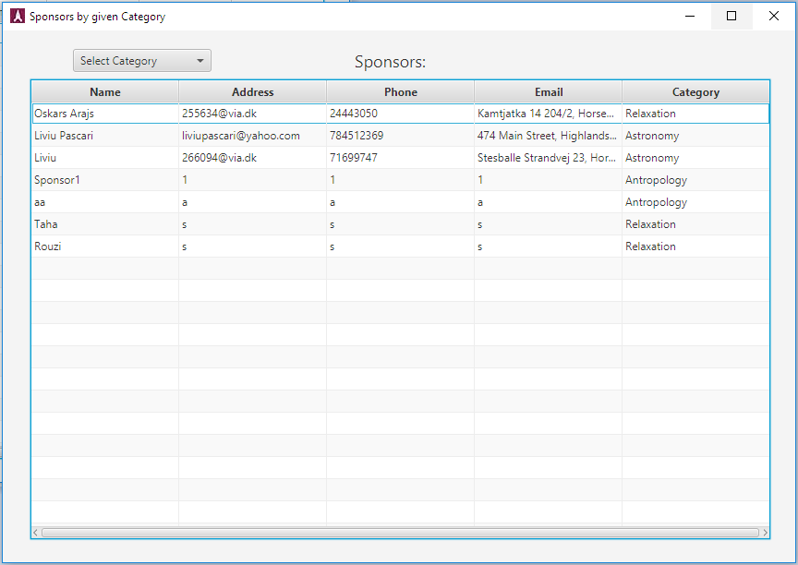

When press on “Sponsors” button in main window, the “Sponsors by given category” window will appear, in this window all Sponsors will appear one by one, by selecting a category from the “combobox” the Sponsors for given category will be shown, otherwise, selecting “show all” will result to show them all again.

**Find None-Members by category** 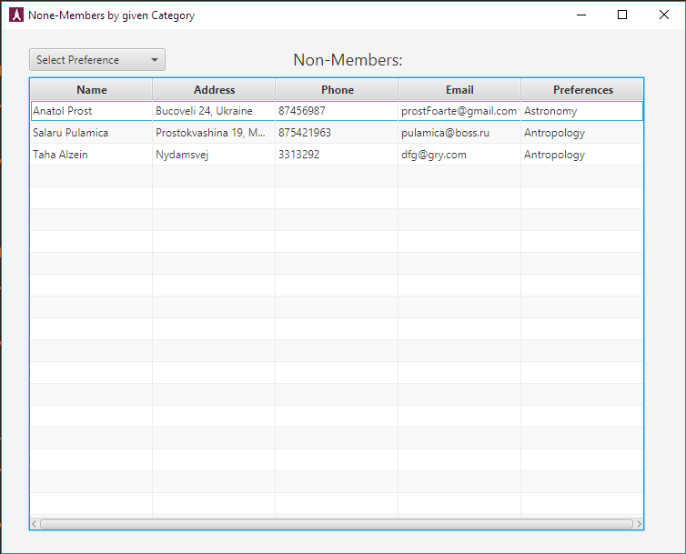

When press on “None-Members” button in main window, the “None-Members by given category” window will appear, in this window all None-Members will appear one by one, by selecting a preference from the “combobox” the None-Members for given preference will be shown, otherwise, selecting “show all” will result to show them all again.

**Find Members by category**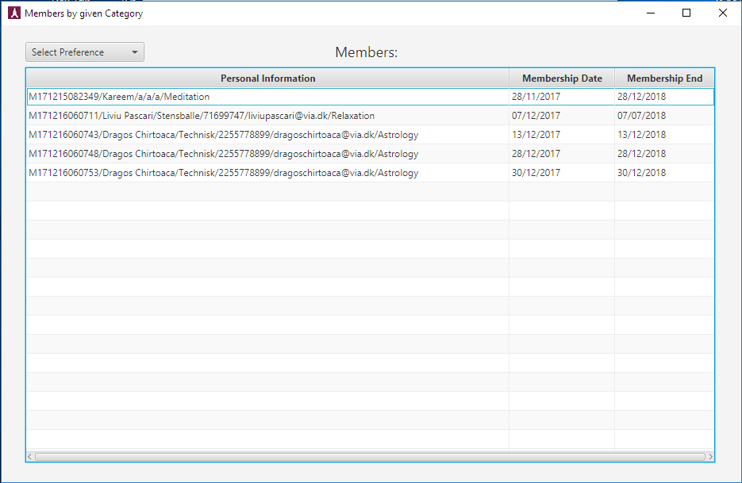

When press on “Members” button in main window, the “Members by given category” window will appear, in this window all Members will appear one by one, by selecting a preference from the “combobox” the Members for given preference will be shown, otherwise, selecting “show all” will result to show them all again.

**Find Members have to pay membership**

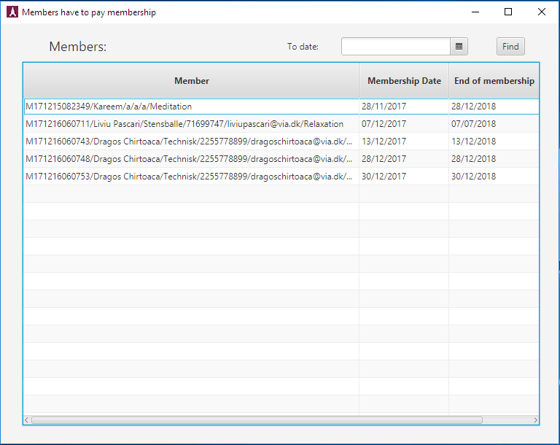

When press on “Members have to pay membership” button in main window, the “Members have to pay membership” window will appear, in this window all Members will appear one by one, there is a possibility to find them by date of ending membership.